**Configure Monitoring - Assignment**

Setting up and configuring monitoring for EC2 instances involves using Amazon CloudWatch, which is a monitoring service provided by AWS. CloudWatch allows you to collect and track metrics, monitor log files, set alarms, and automatically react to changes in your AWS resources.

1. **Create a separate VPC and EC2 instance to setup monitoring**

* Create a VPC

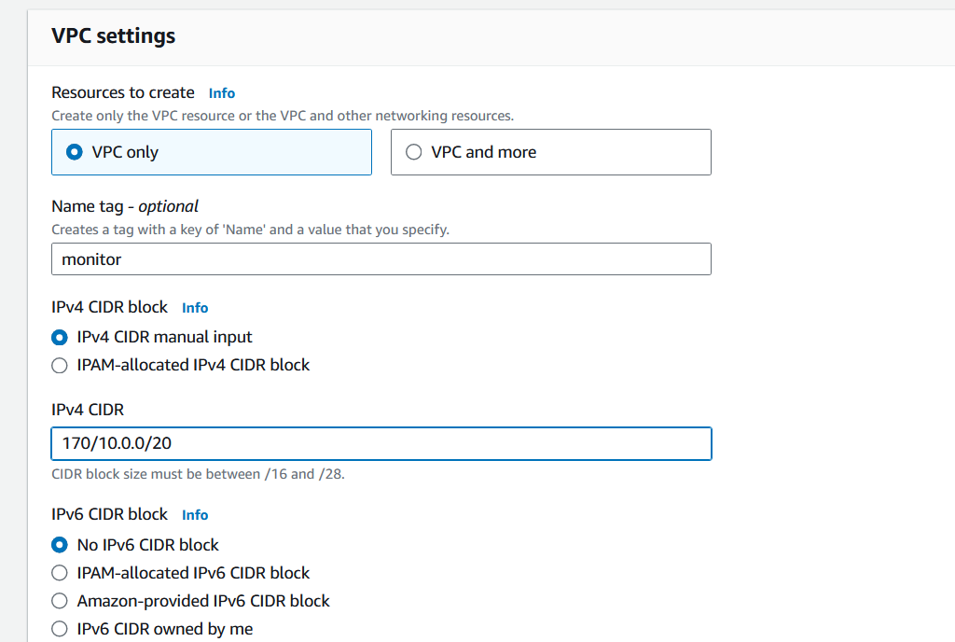

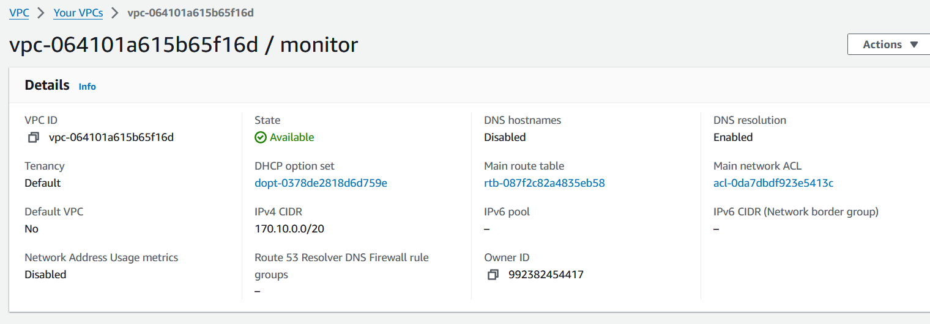

* Create a Subnet

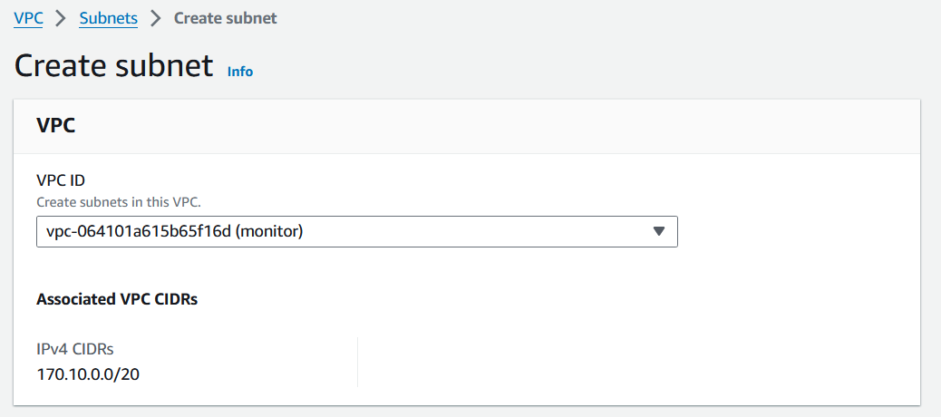

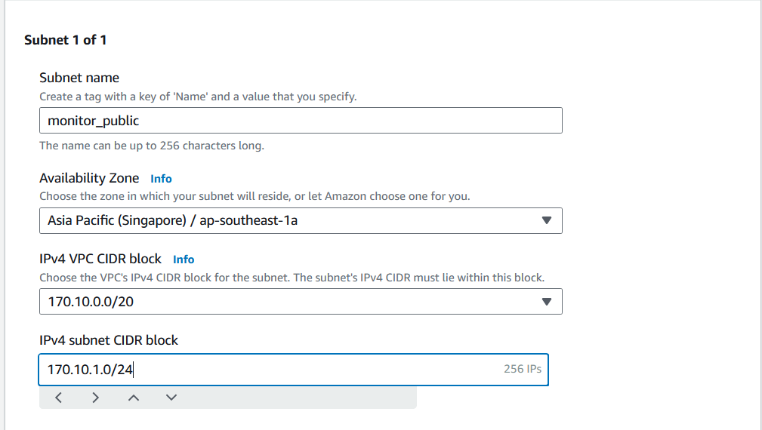

* Create a Route table

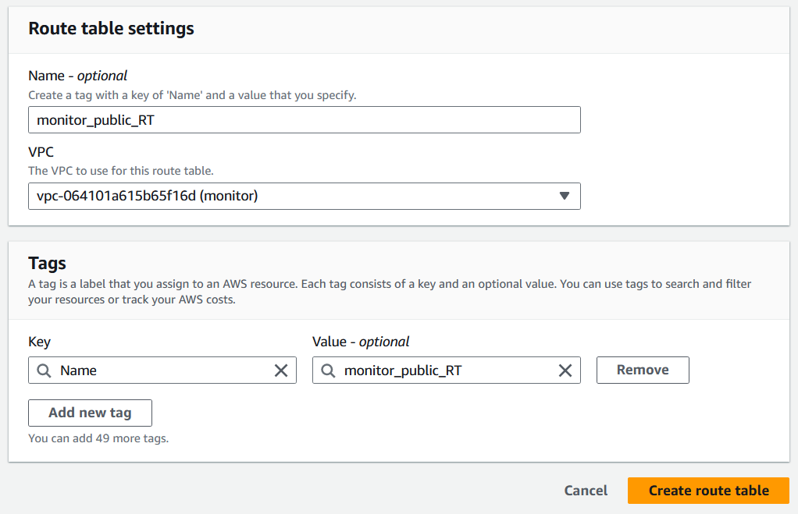

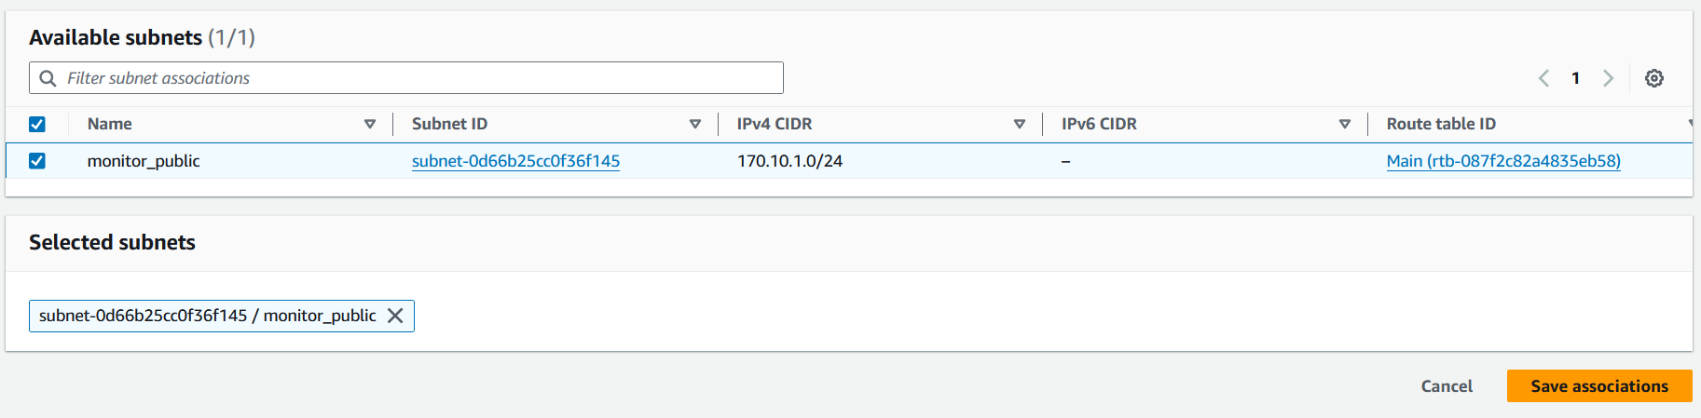

* Create an Internet Gateway

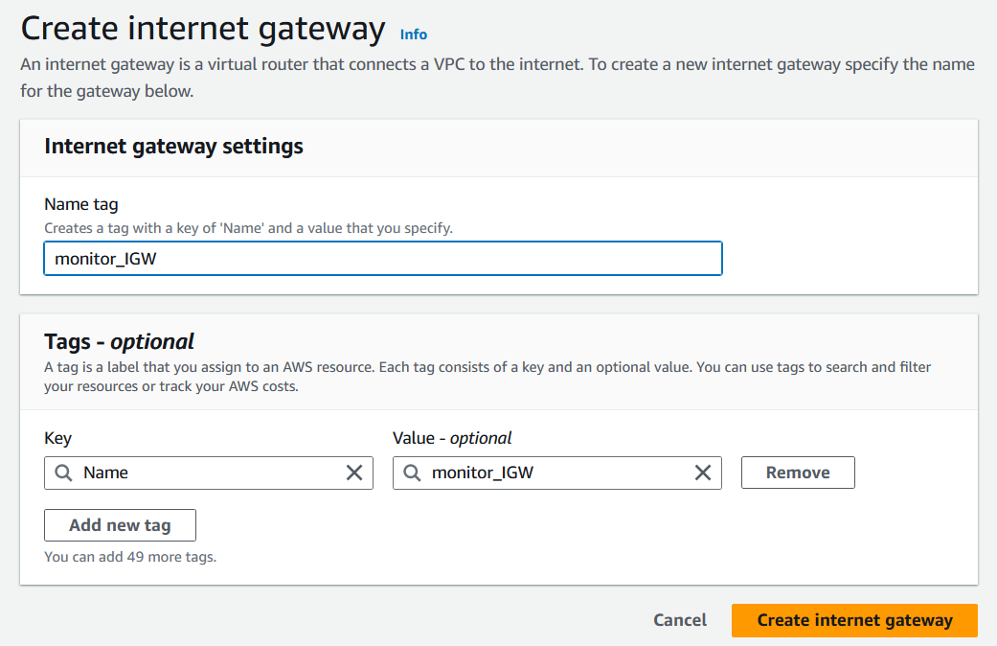

* Attach the IGW to the VPC

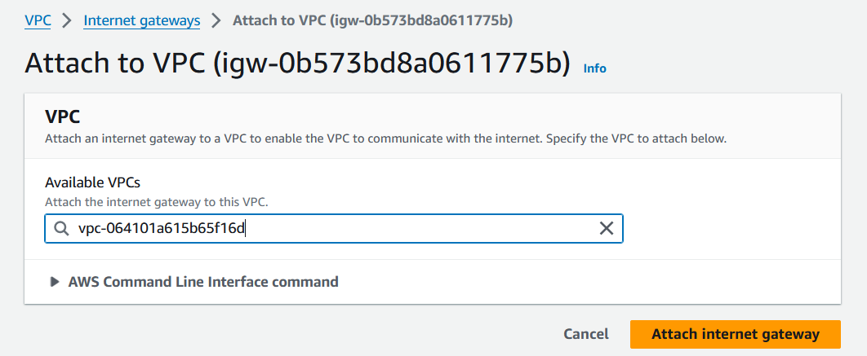

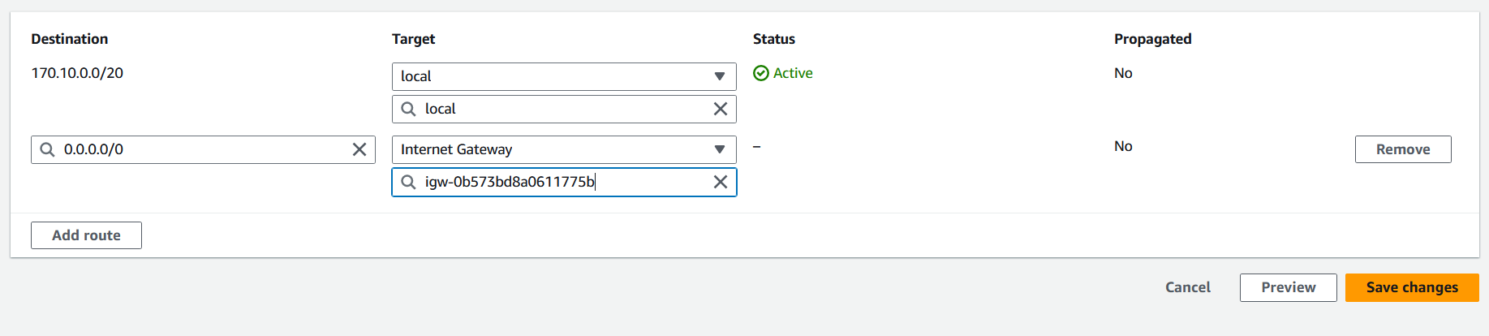

* Create a Security group

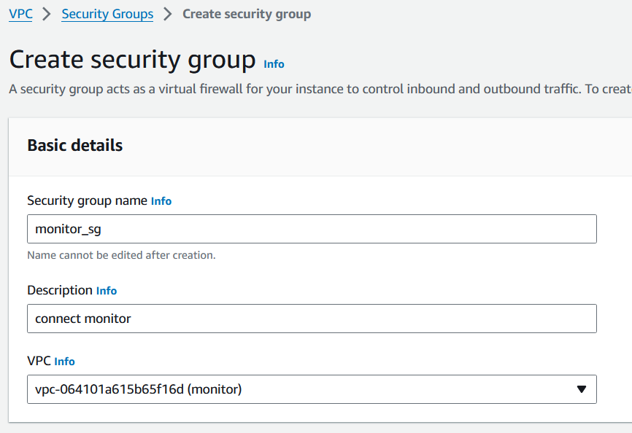

* Launch an instance

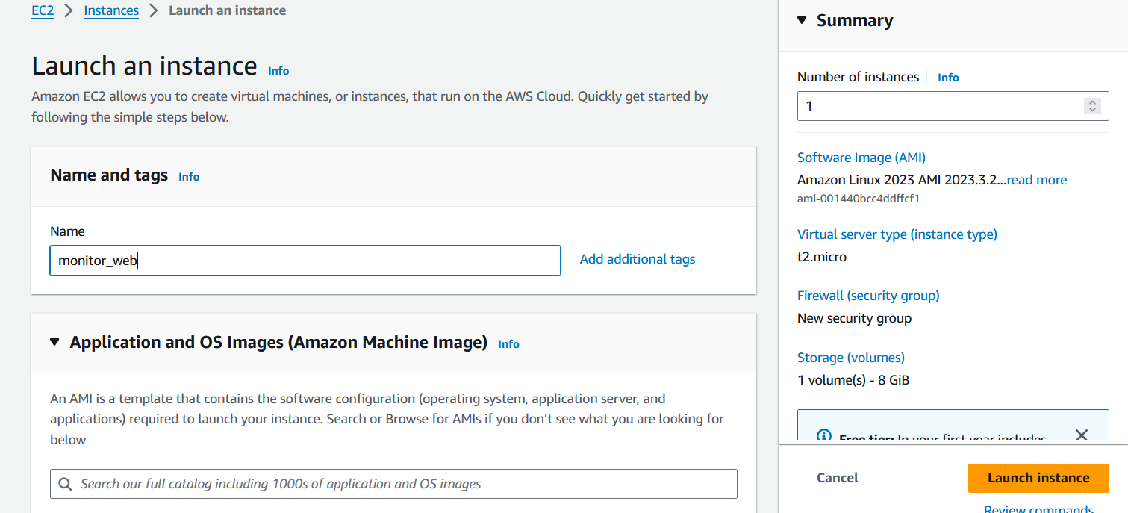

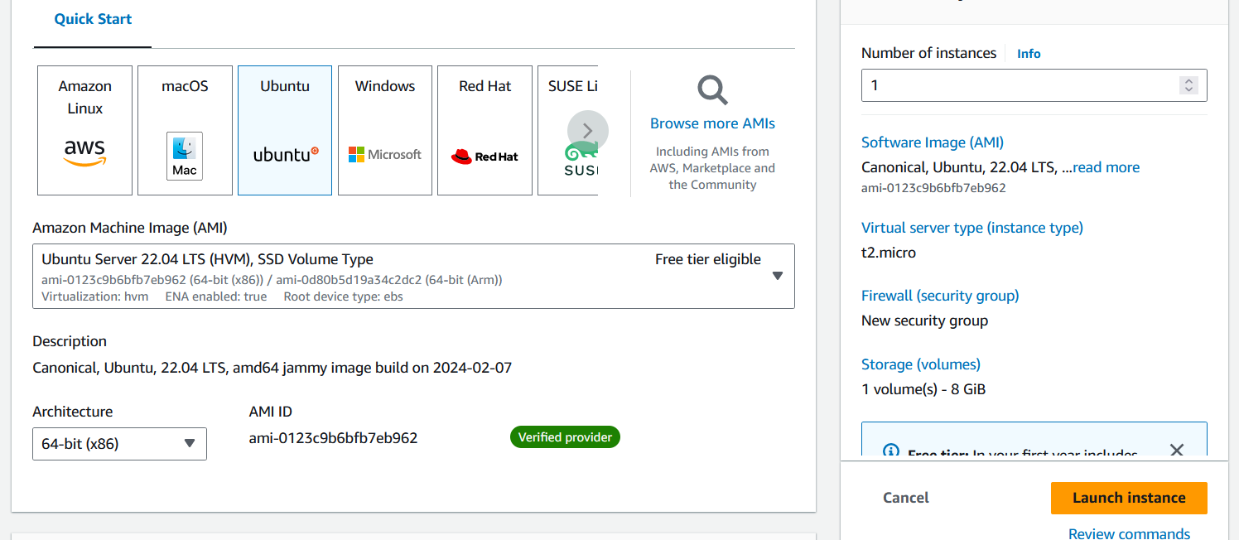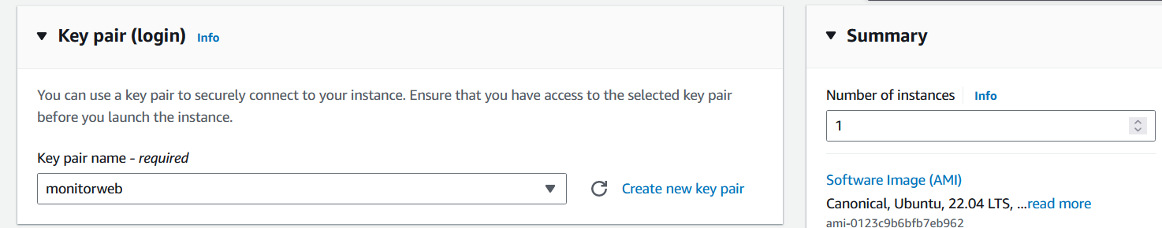

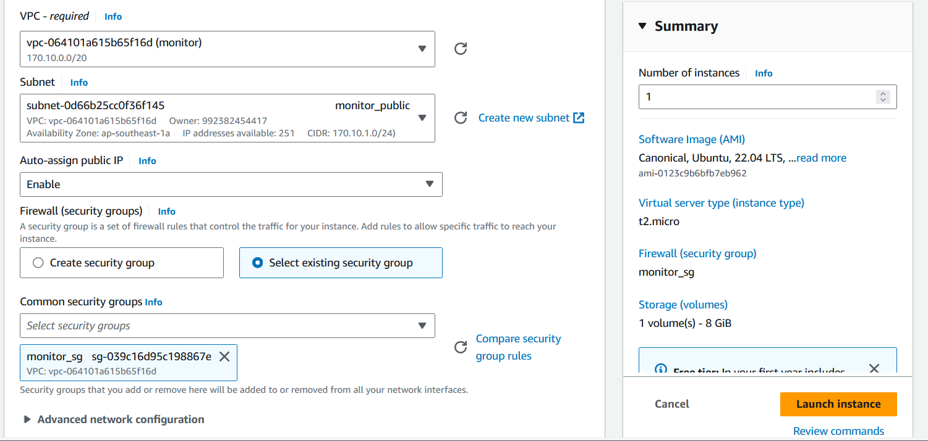

Once the environment is setup, let us move on to initiate monitoring

1. **Enable Detailed Monitoring**:

* By default, CloudWatch provides basic monitoring for EC2 instances which samples metrics every five minutes.
* To enable detailed monitoring, From the "Actions" menu, choose "Monitoring" and then "Enable detailed monitoring."

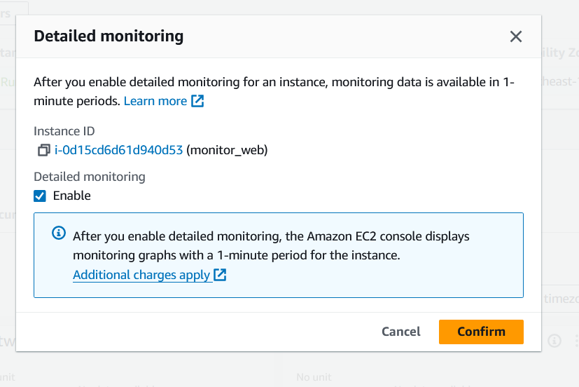

* Create a new dashboard to view the chosen metrics

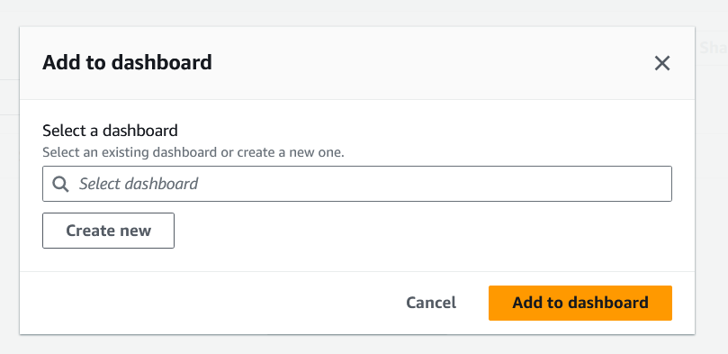

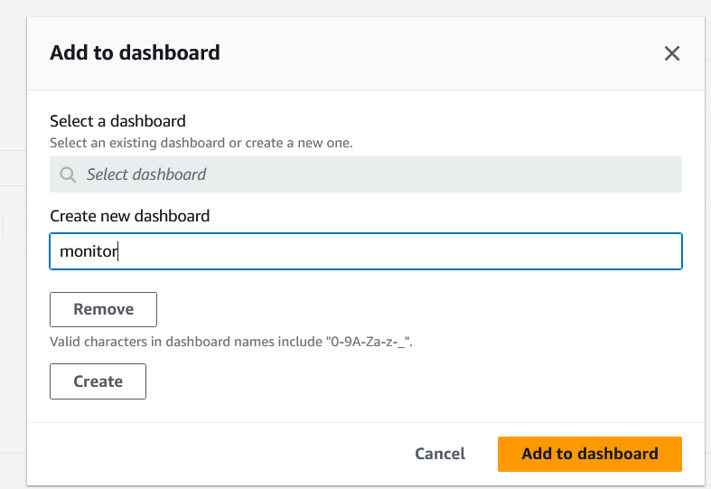

* The dashboard is created and the default metrics are loaded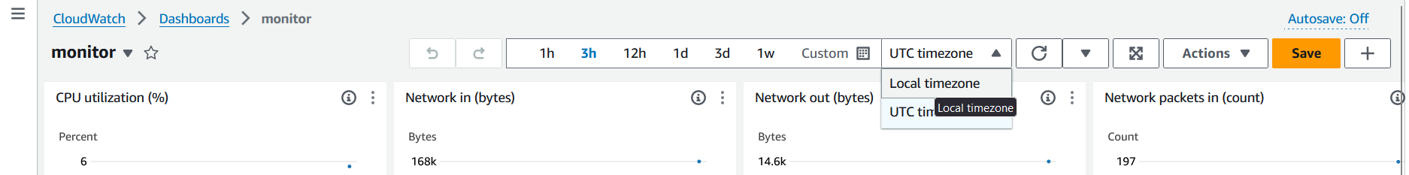

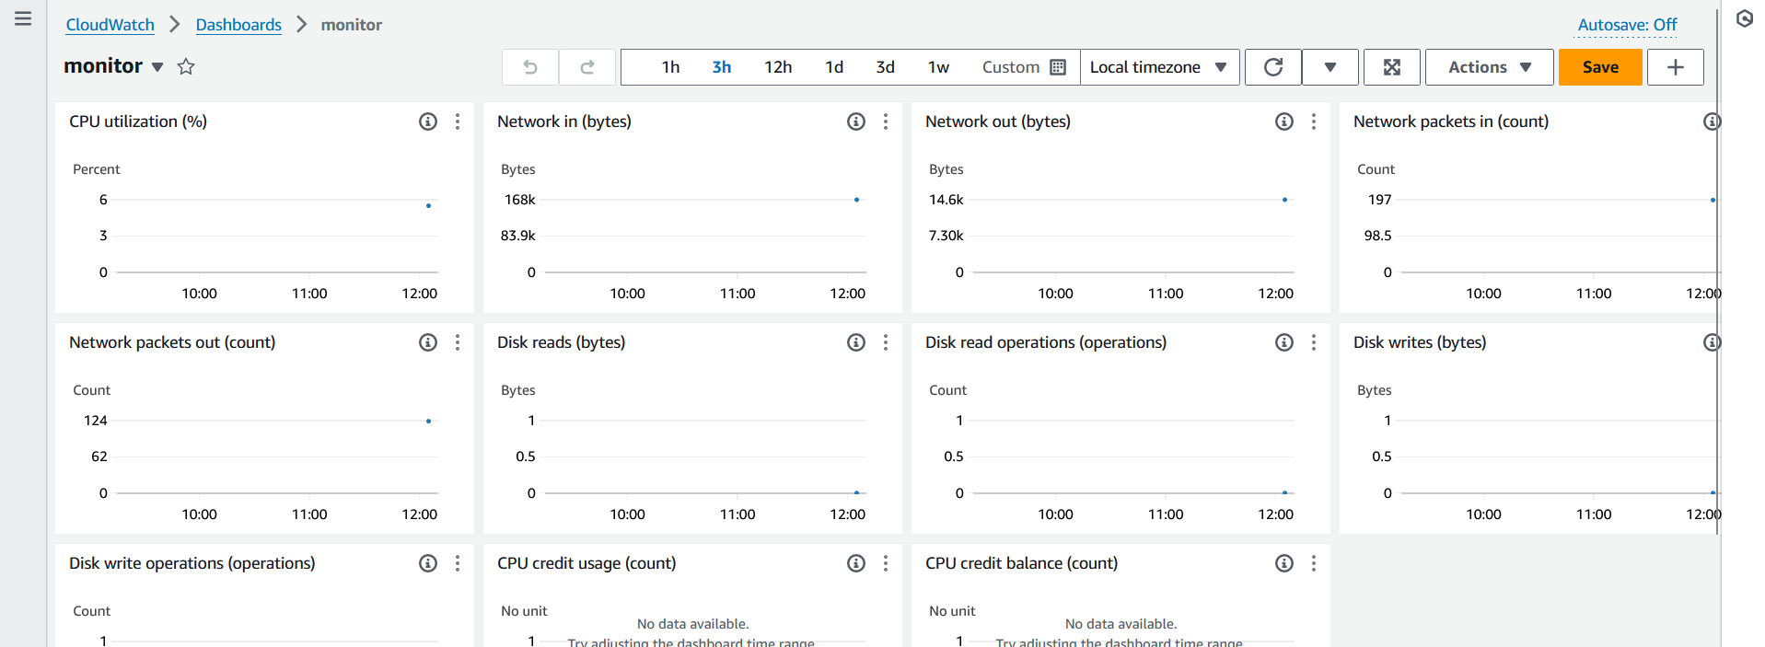

1. **Monitor the instance**:

The instances are subjected to various loads to monitor the behaviour

Initially, the instance is loaded with updates and installation of web server.

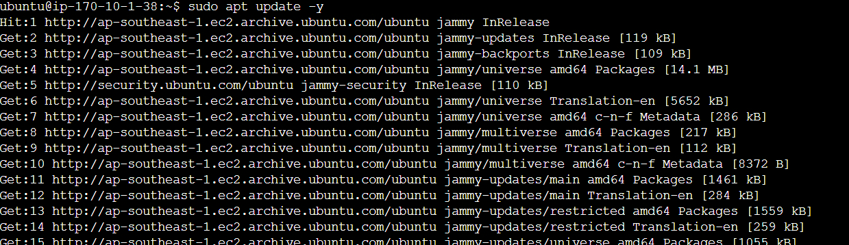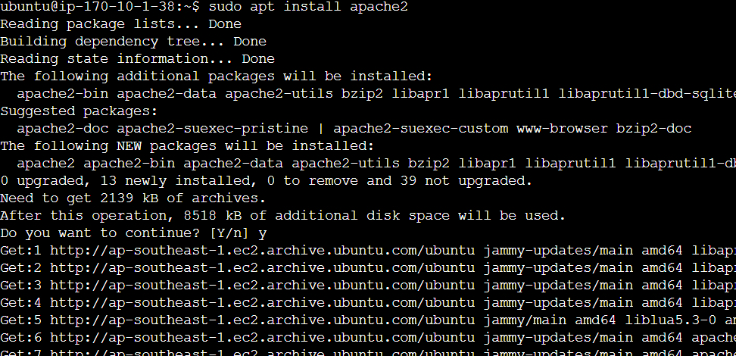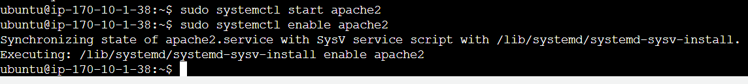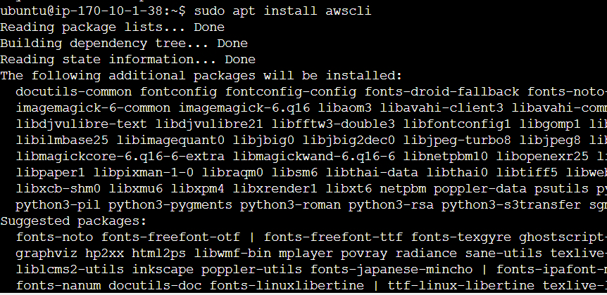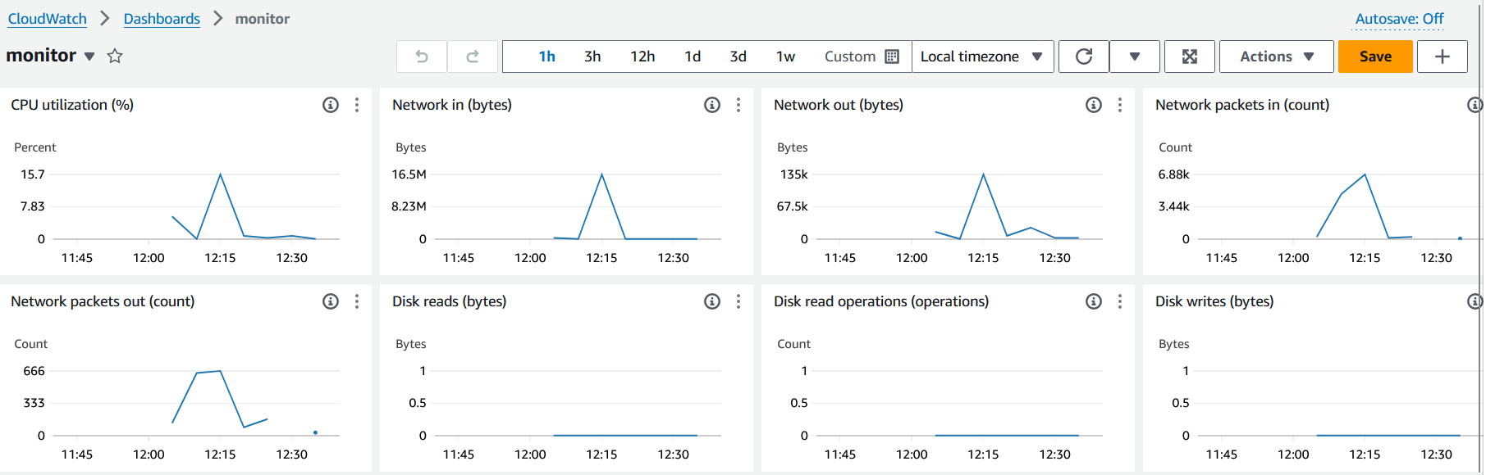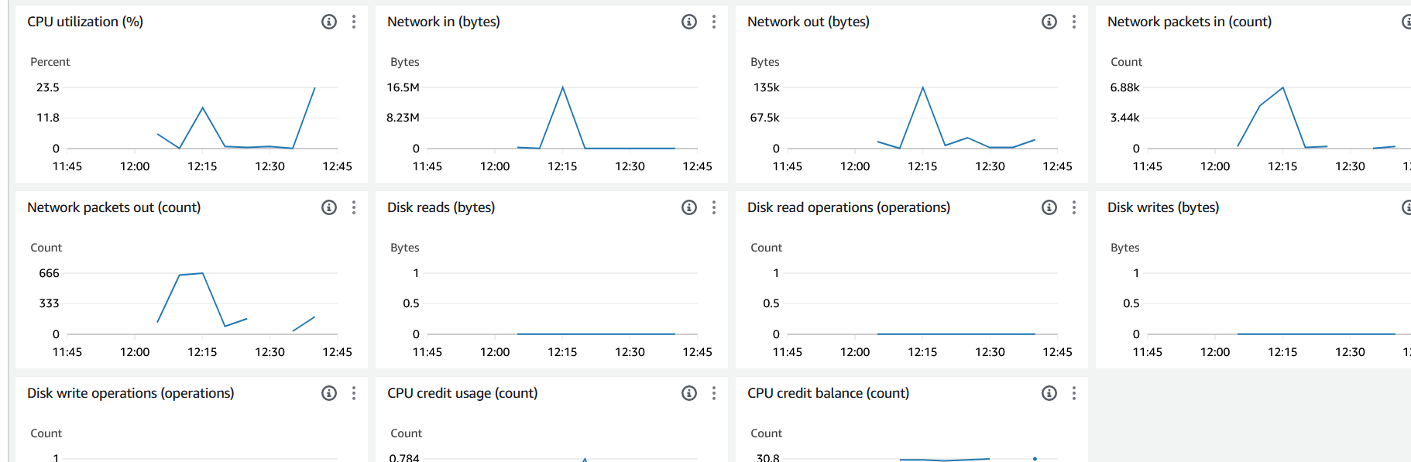

We can observe the instance being monitored for CPU utilization and network metrics.

1. **Create and test Alarms**:

* The CPU is to be monitored for CPU utilization.

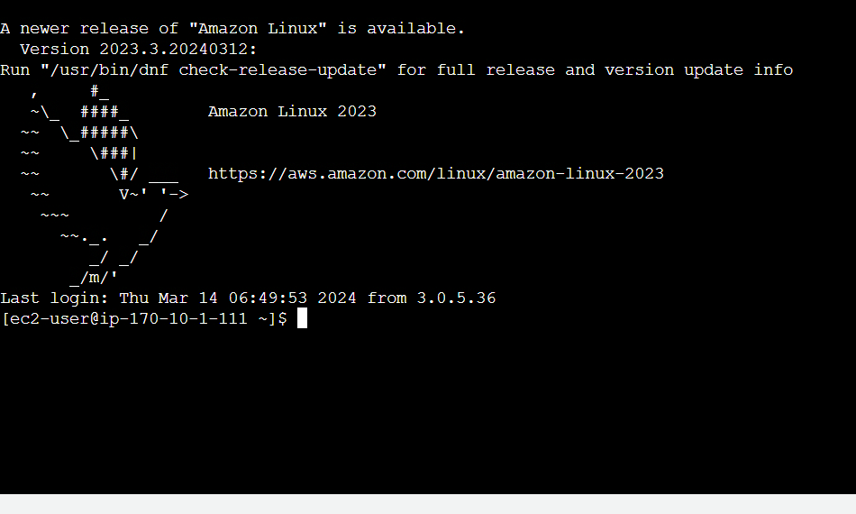

* Install stress: If stress is not already installed on your Amazon Linux instance, you can install it using the package manager:

sudo yum install stress

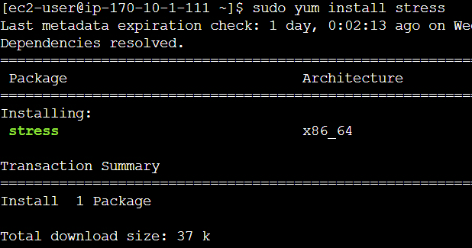

* An alarm is setup to monitor CPU utilization

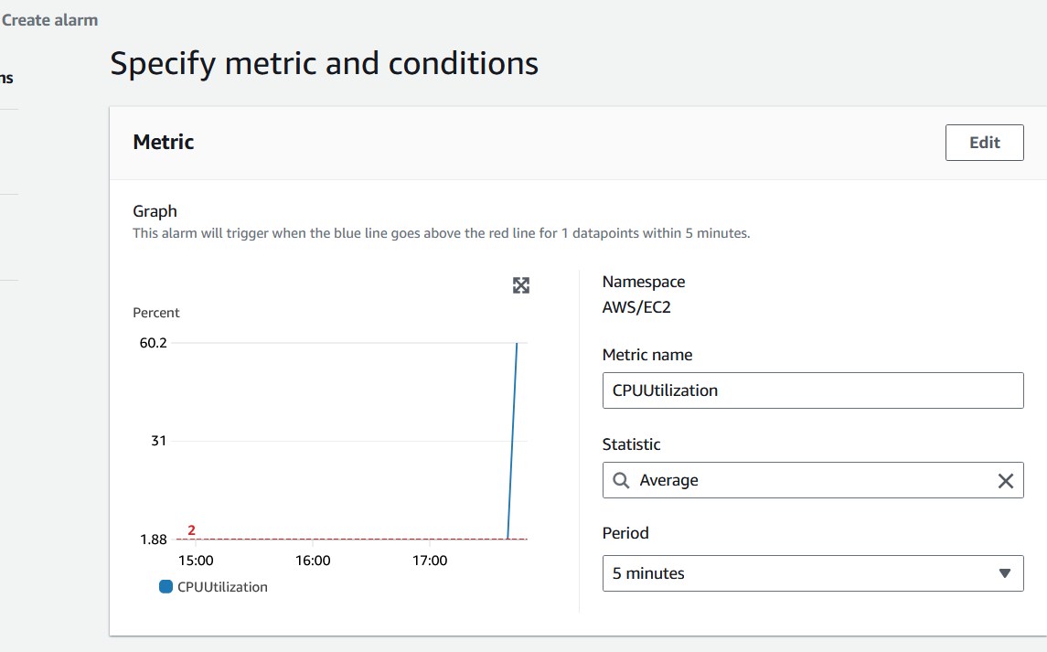

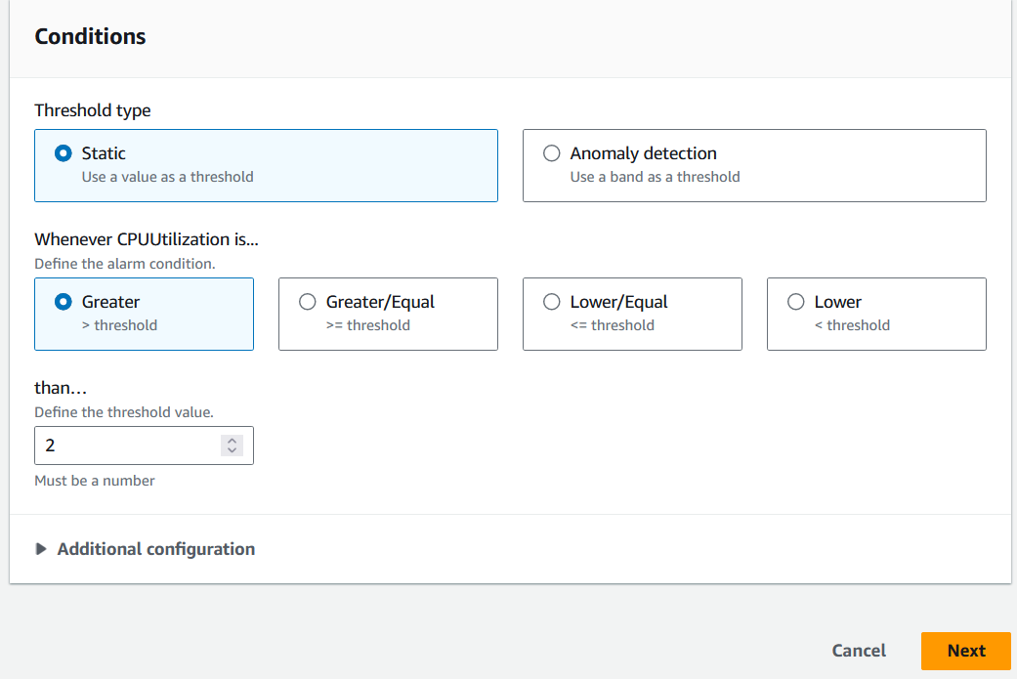

* An alarm action is to be setup to send notifications

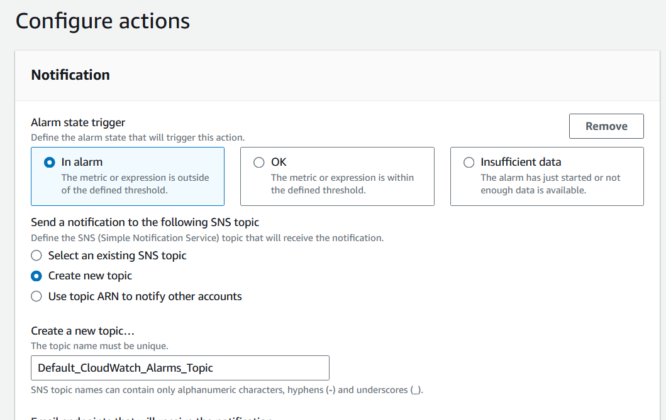

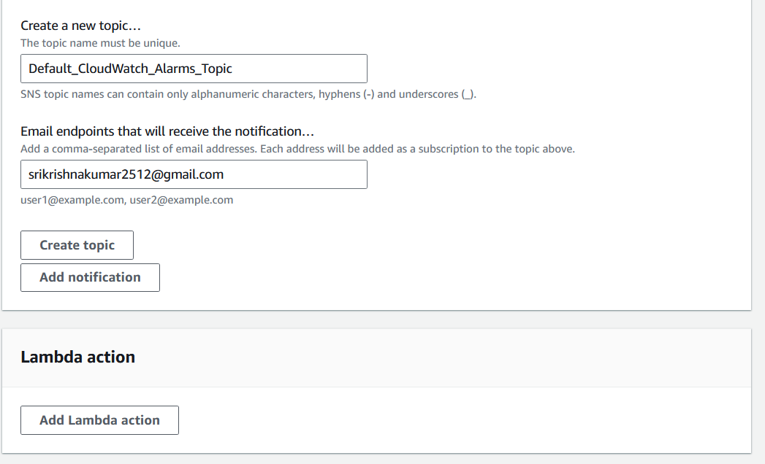

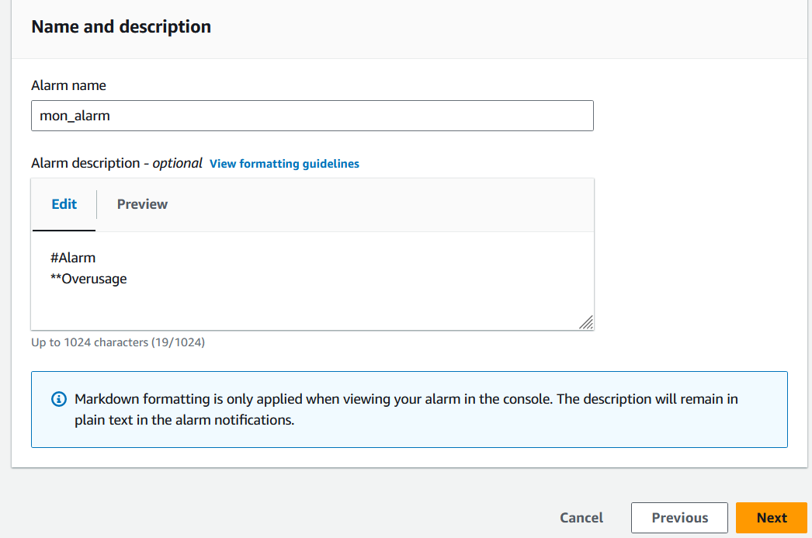

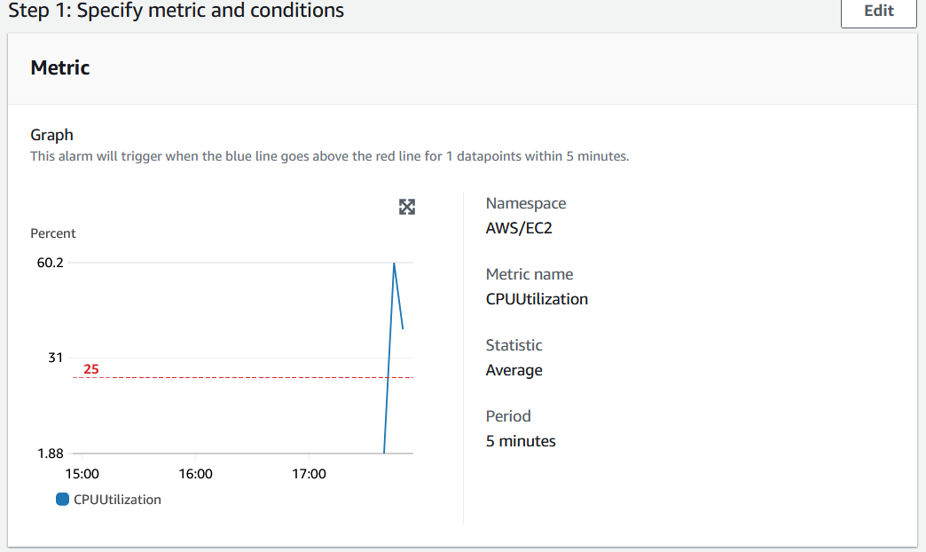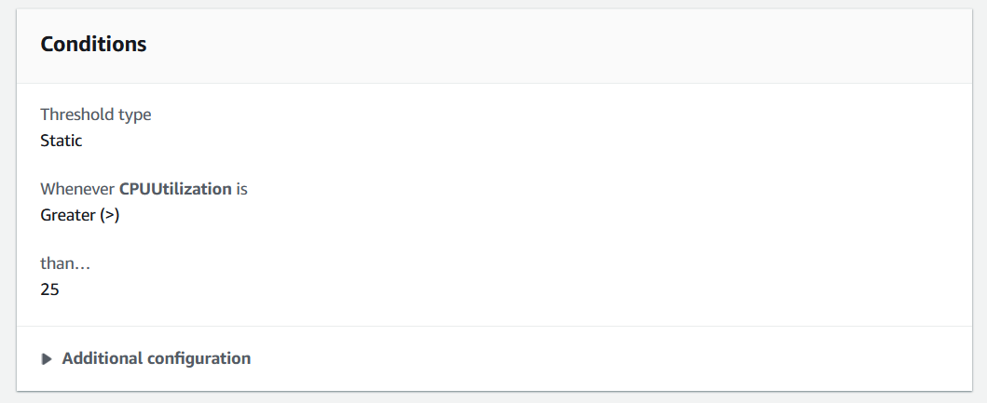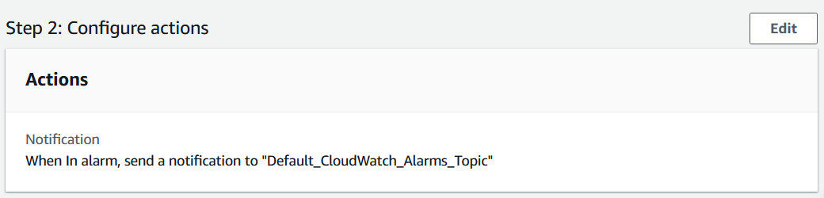

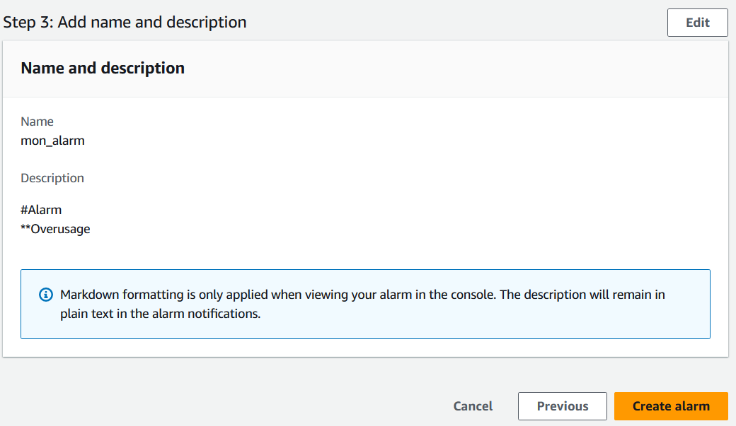

* An alarm subscription will be confirmed through SNS

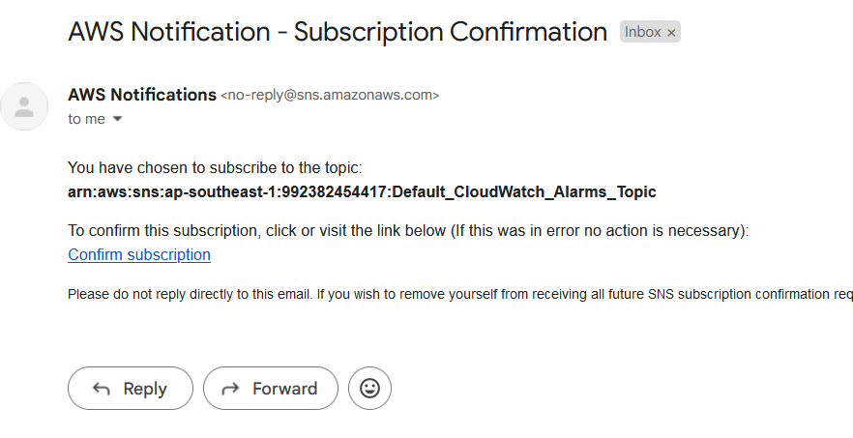

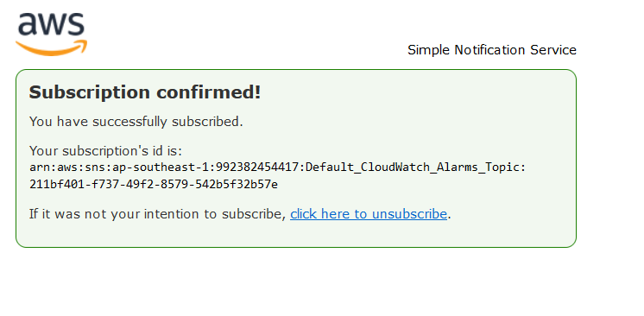

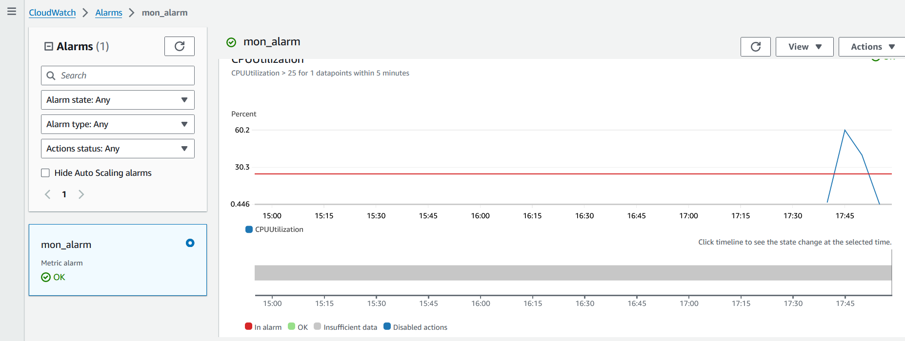

**Run stress to Generate CPU Load**: Run stress to simulate CPU load on your EC2 instance. For example, you can simulate load on all CPU cores for a specified duration:

bash

• stress --cpu $(nproc) --timeout 300s

This command will stress all available CPU cores ($(nproc) gets the number of CPU cores) for 5 minutes (--timeout 300s). You can adjust the number of CPU cores and the duration as needed.

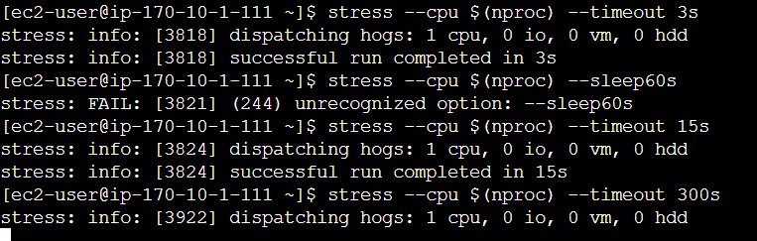

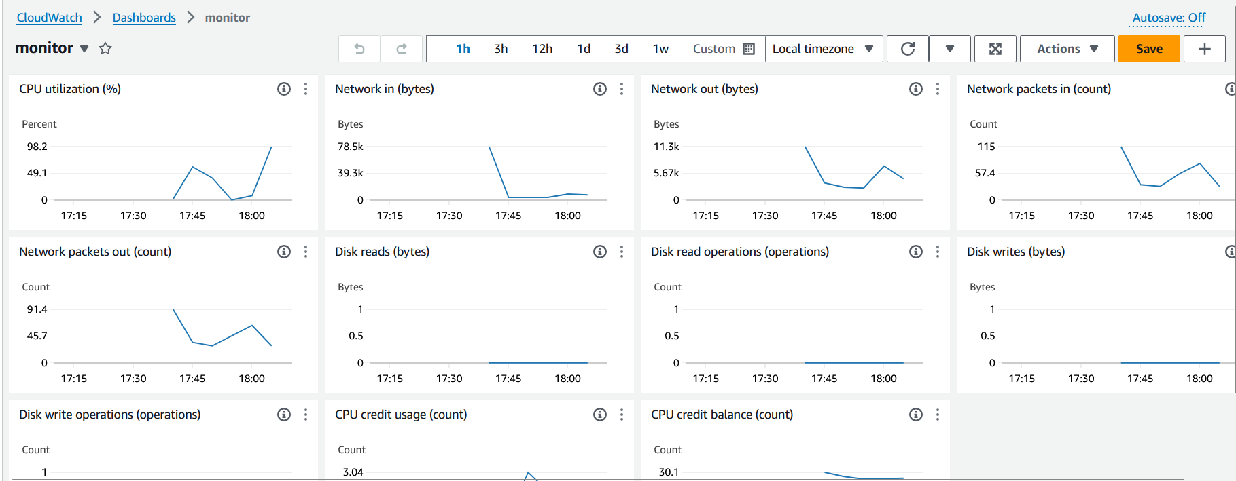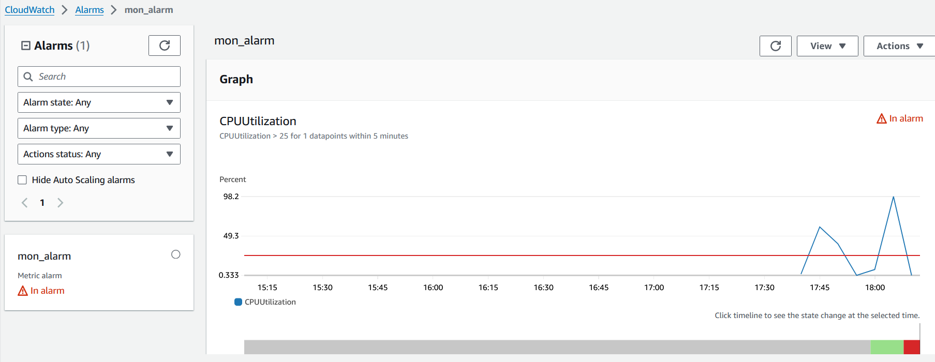

* The CPU utilization is monitored and SNS activates as soon as the threshold is breached.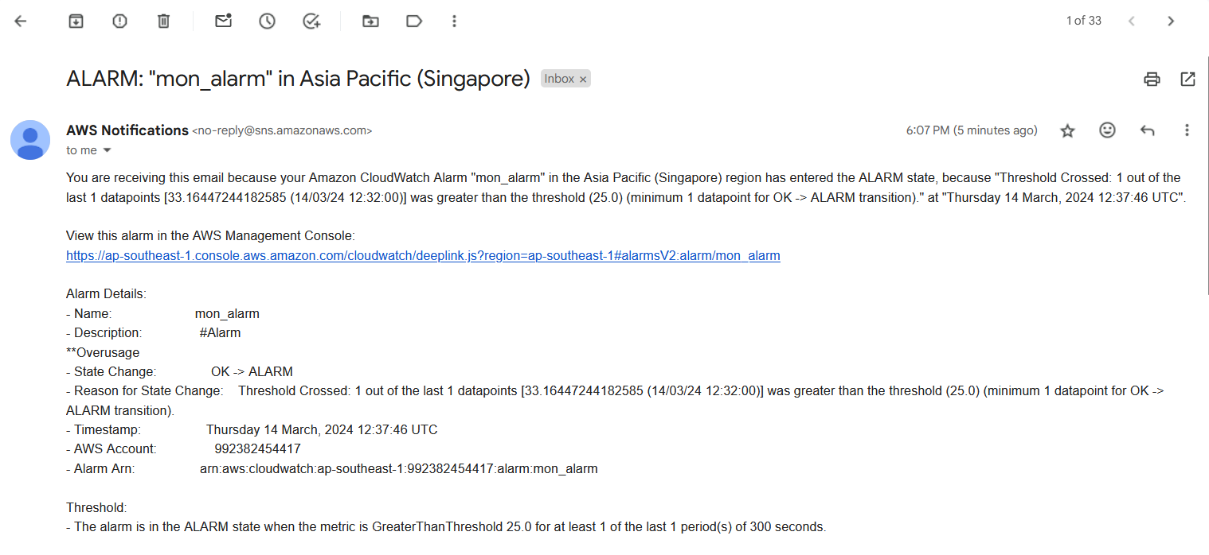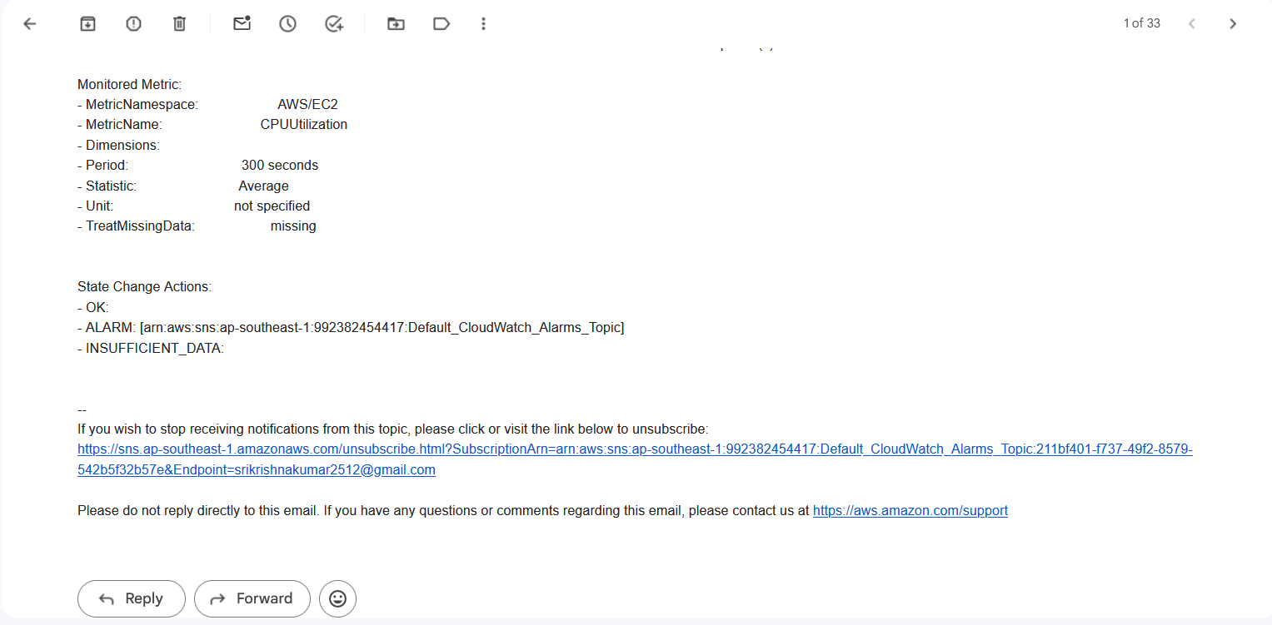



* Various loads and network utilization is triggered for monitoring purposes

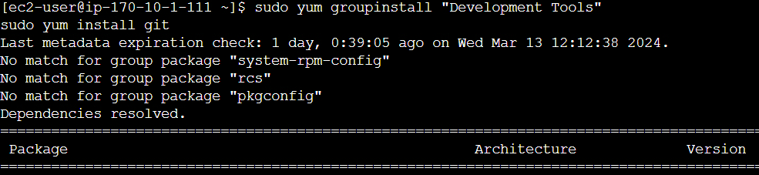

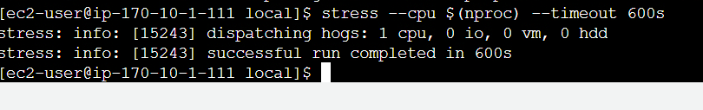

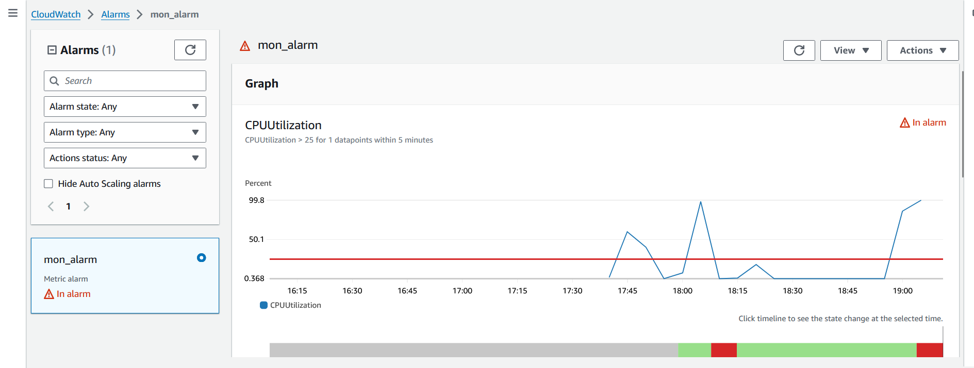

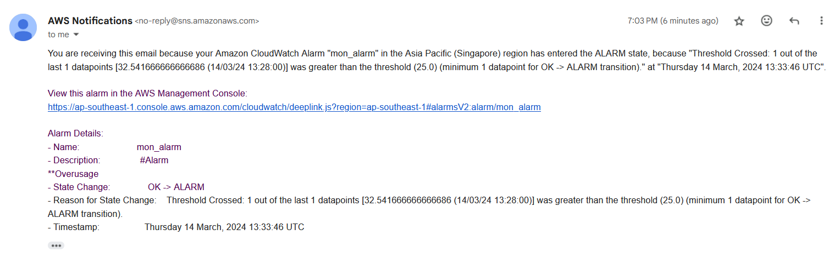

**Setting up and configuring monitoring for Amazon S3**

Setting up and configuring monitoring for Amazon S3 involves utilizing Amazon CloudWatch and S3's built-in logging features

1. **Enable Server Access Logging**:

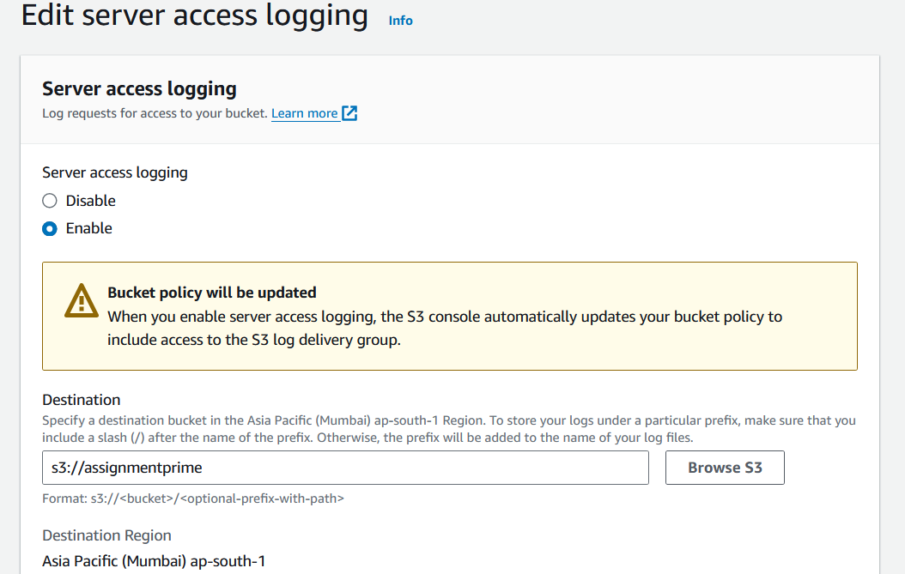 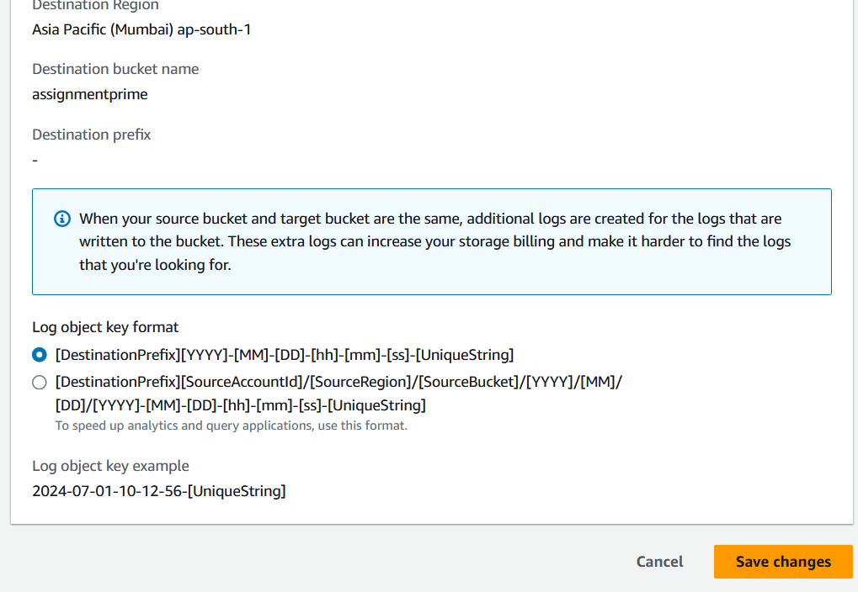

1. **Observe the basic metrics of S3 bucket**

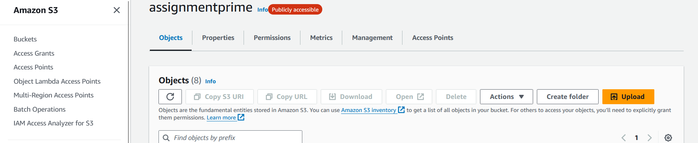

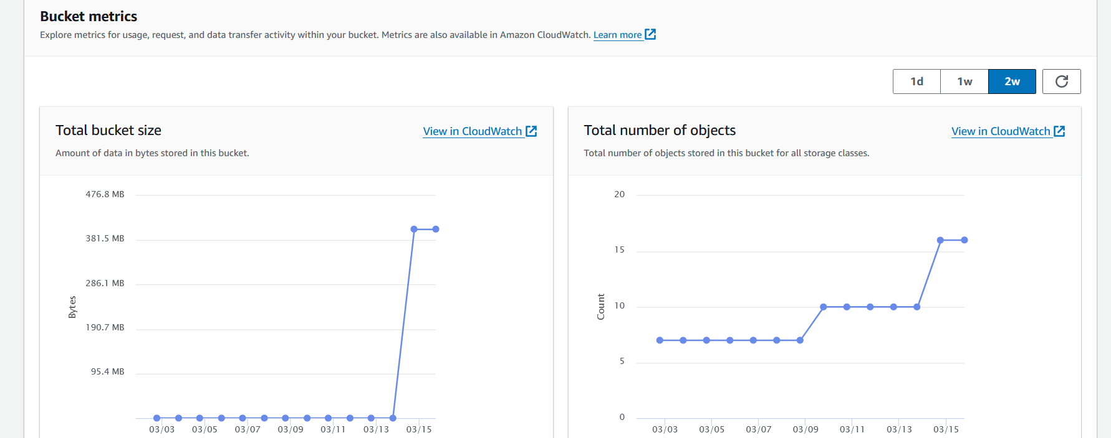

* Vary the timeline and observe the changes.

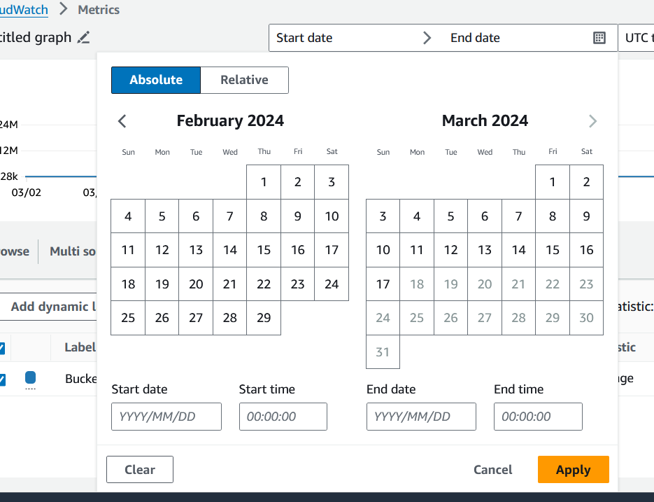

* Changes in the bucket size due to addition of objects can be observed graphically and can be exported as csv as a detailed log.

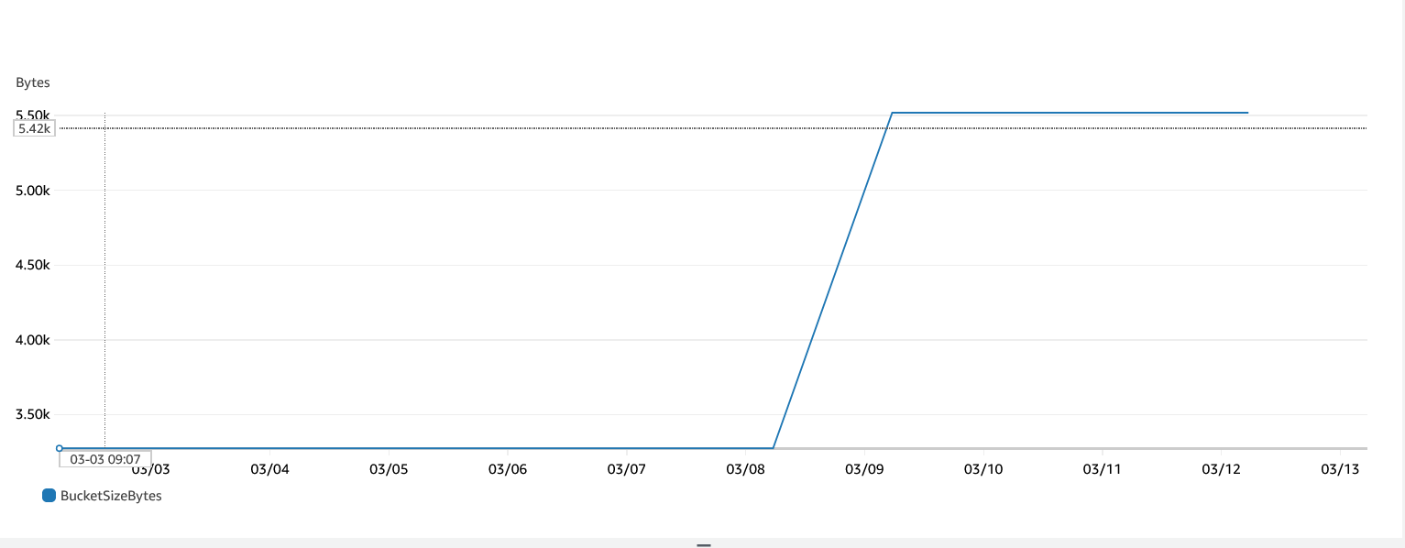

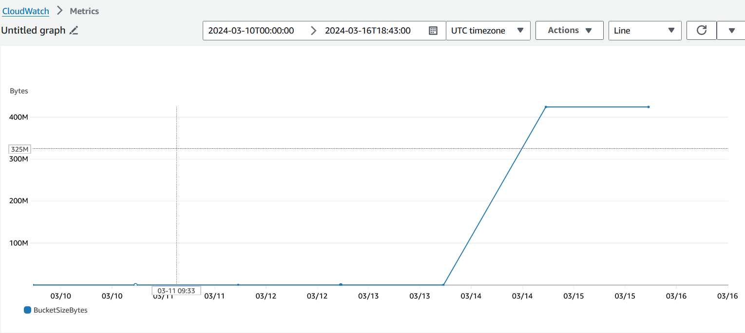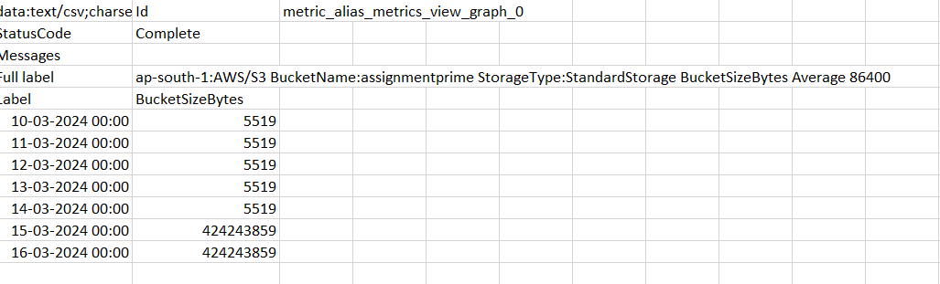

* Changes in the number of objects due to addition of objects can be observed graphically and can be exported as csv as a detailed log.

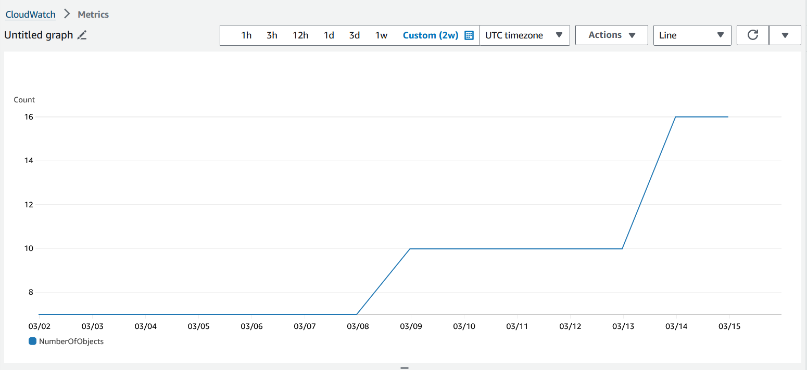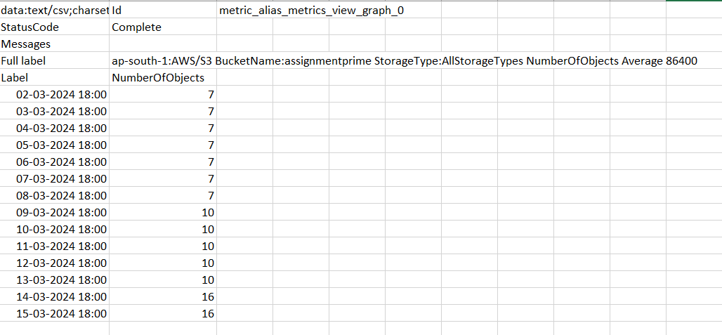

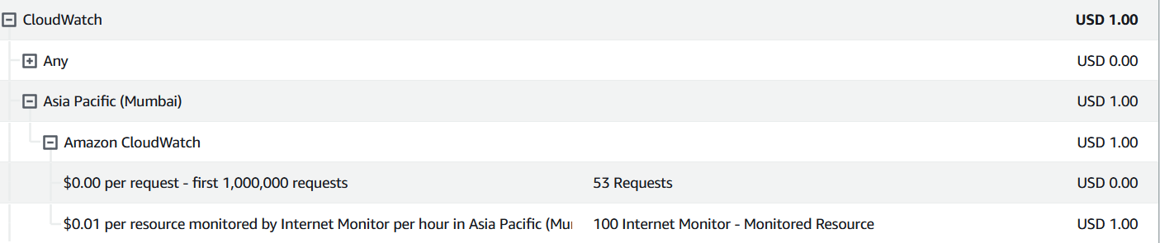

* Additional alarms and SNS can be configured for S3 bucket.

Choose metrics and specify the conditions

Configure the Action

Add a name and describe the alarm

Verify and create the alarm

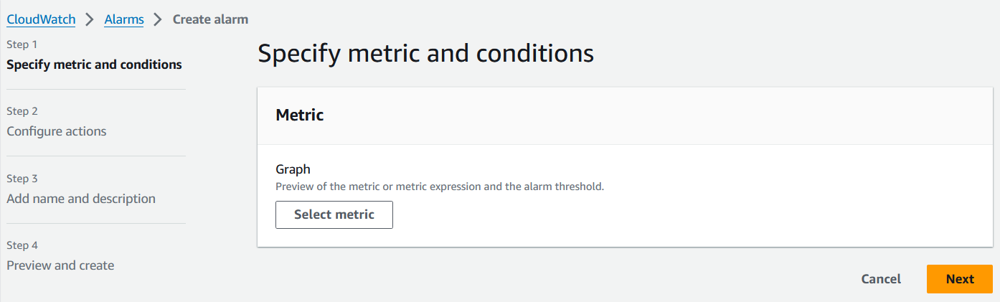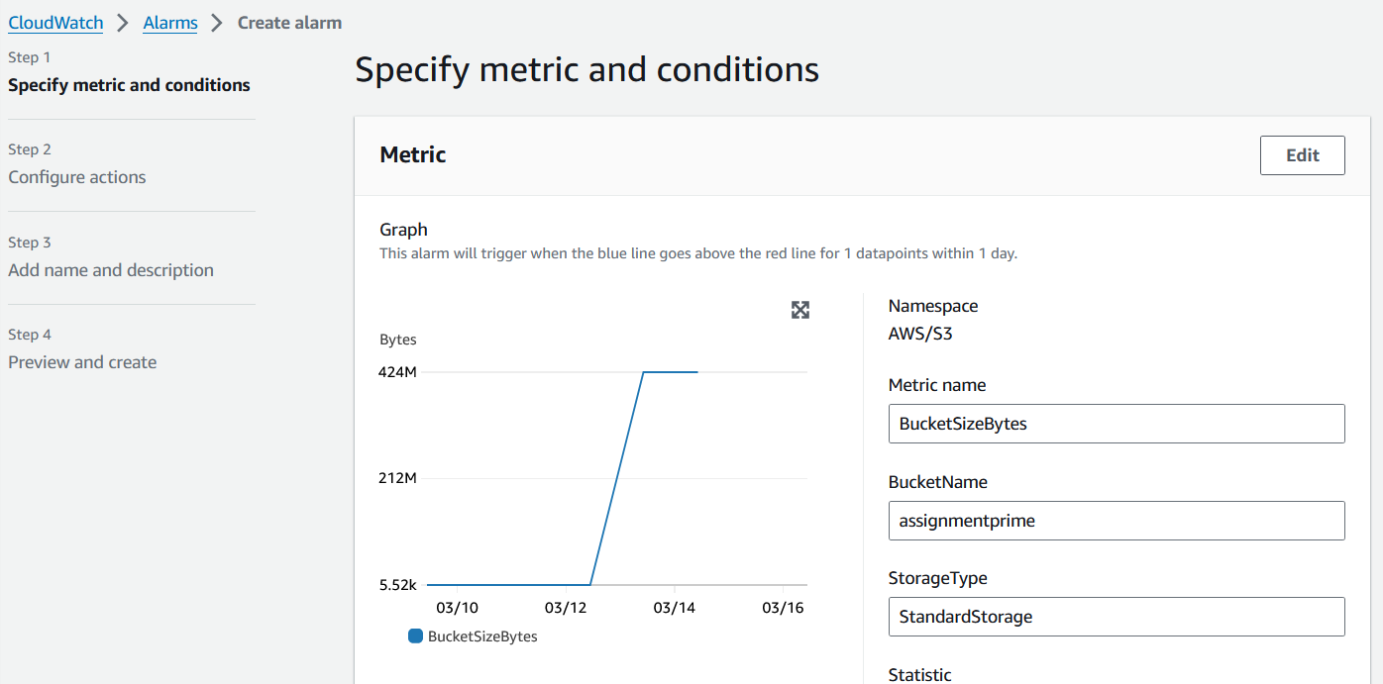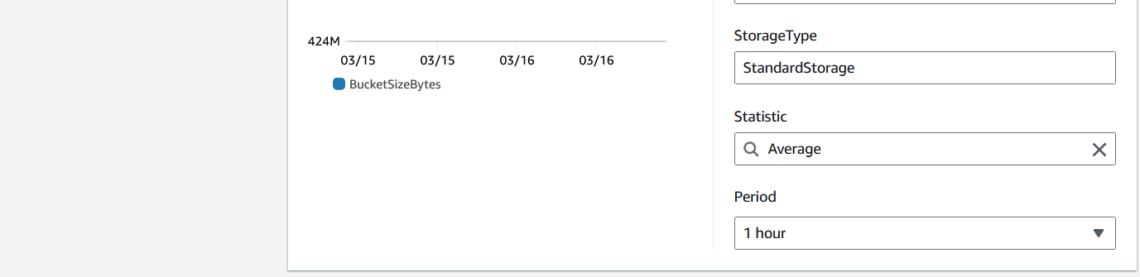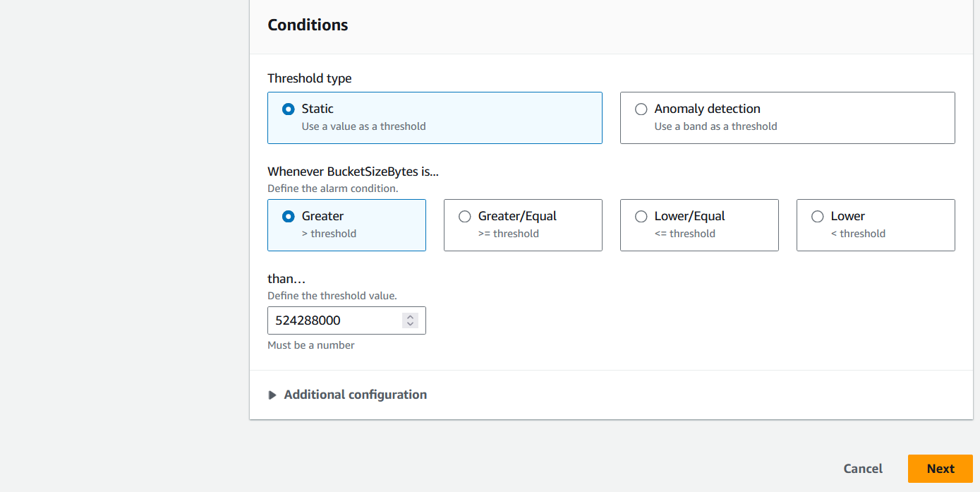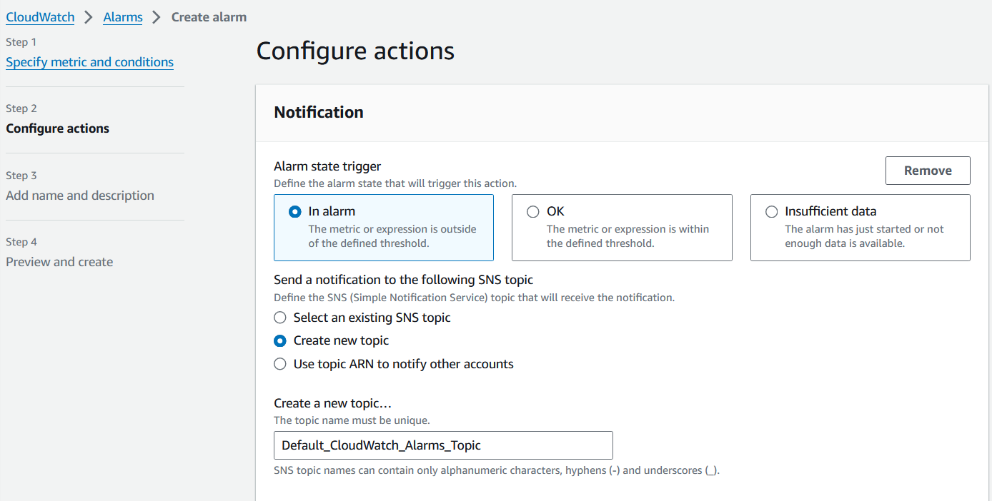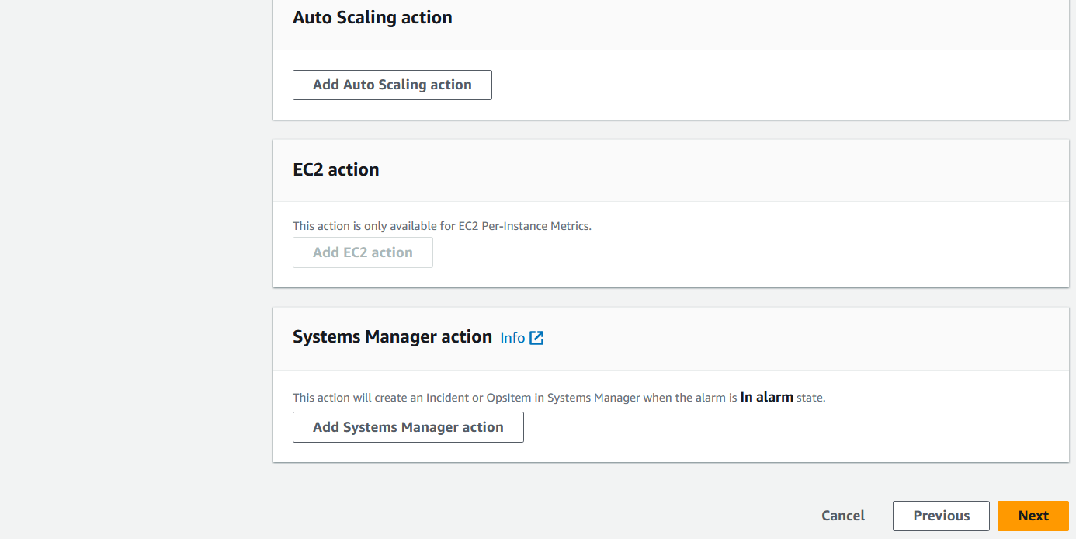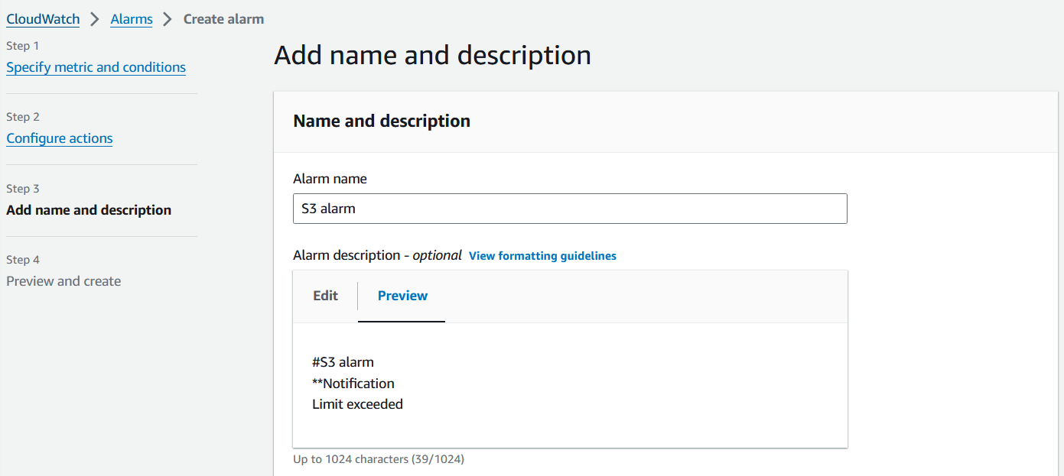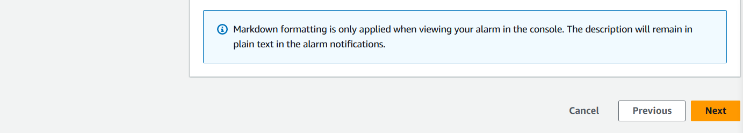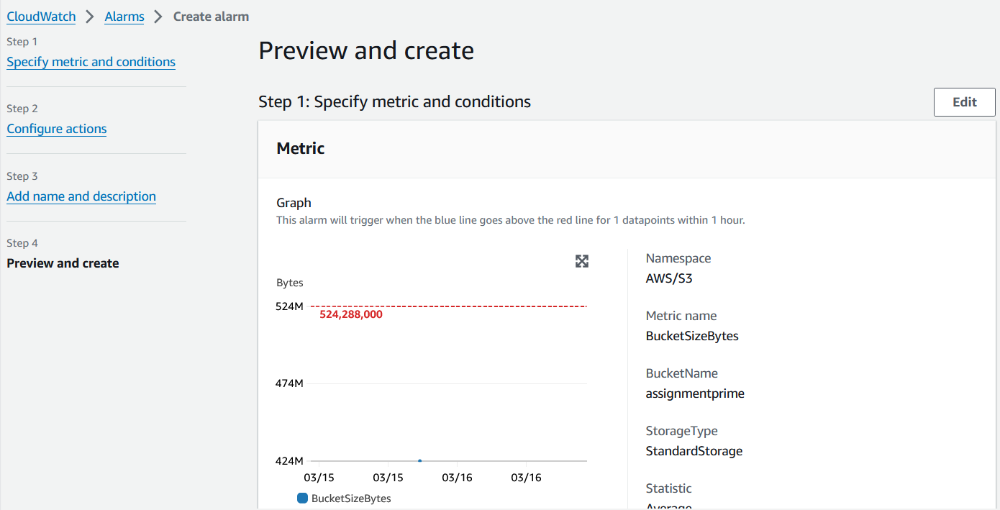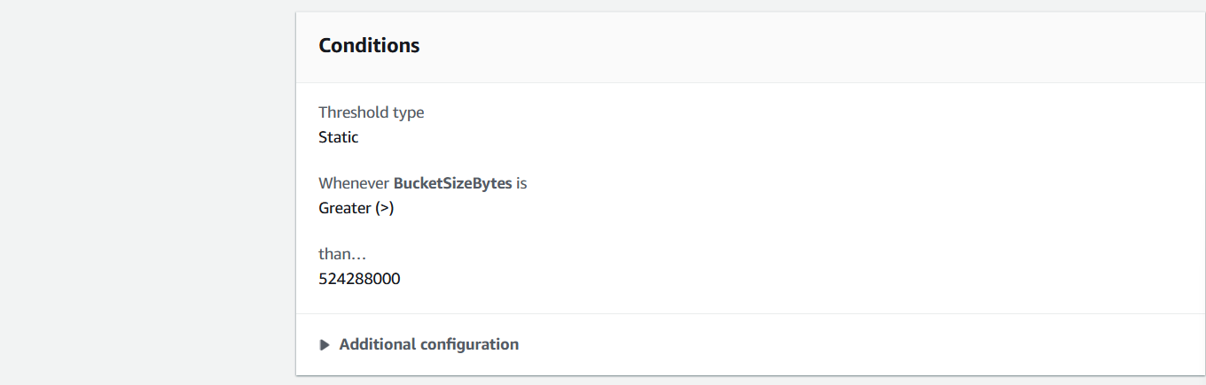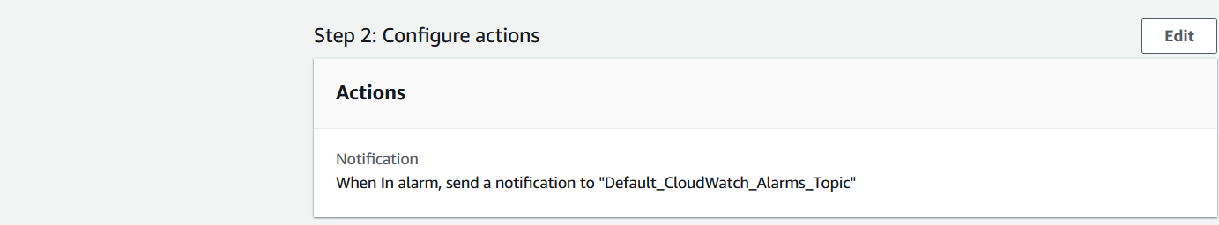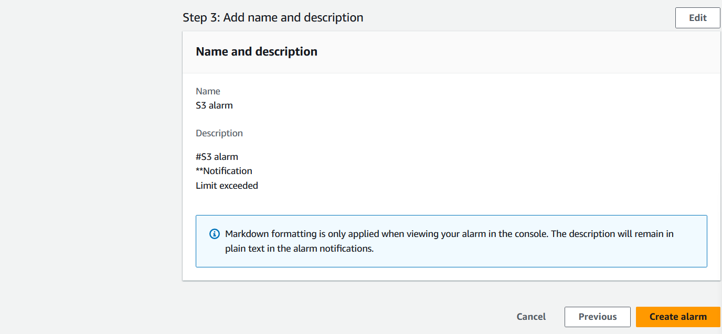

* Trigger the alarm to enable the notification services to notify the alarm to the predefined people.

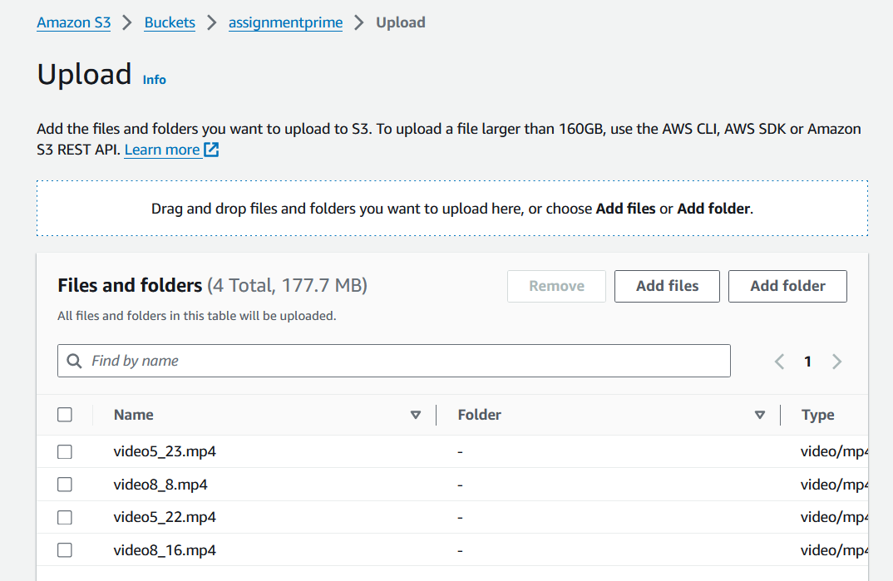

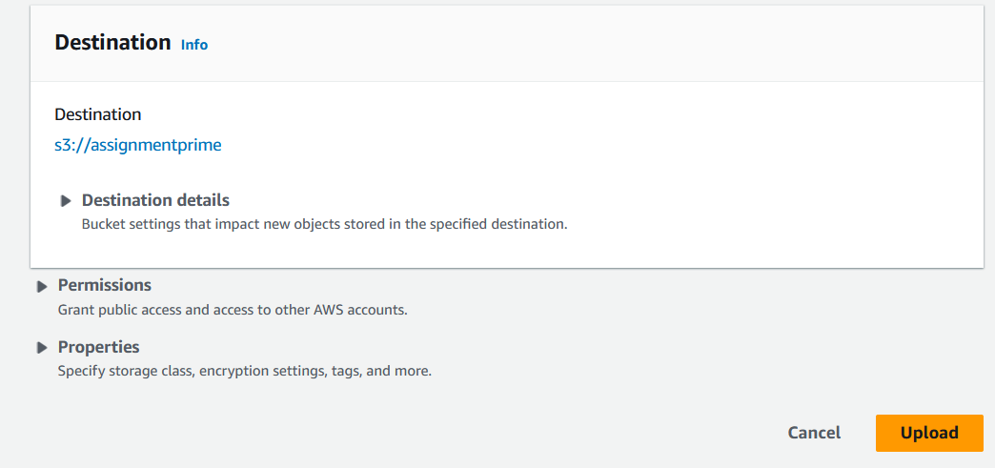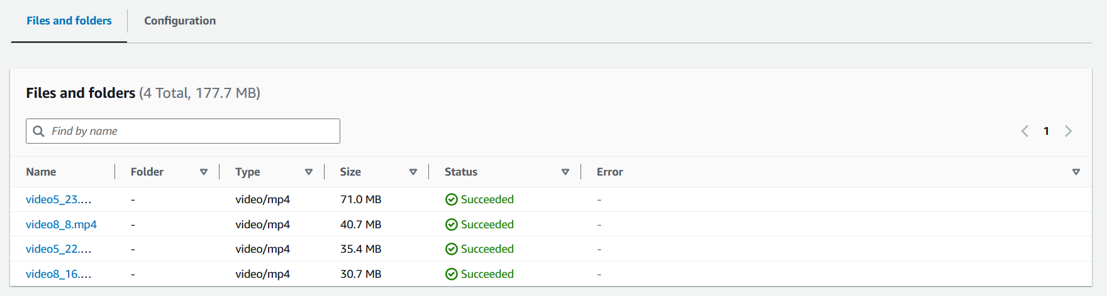

* Confirm the subscription and AWS notification will be enabled.

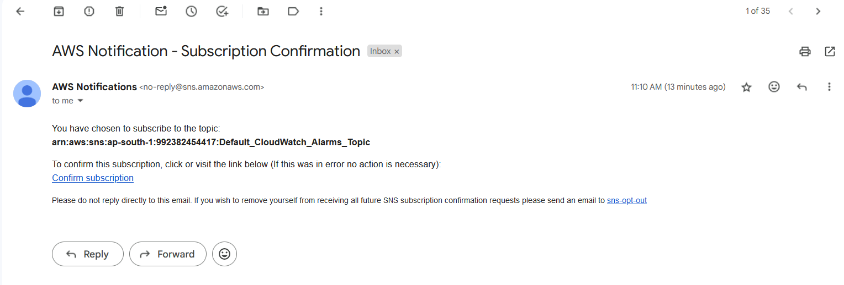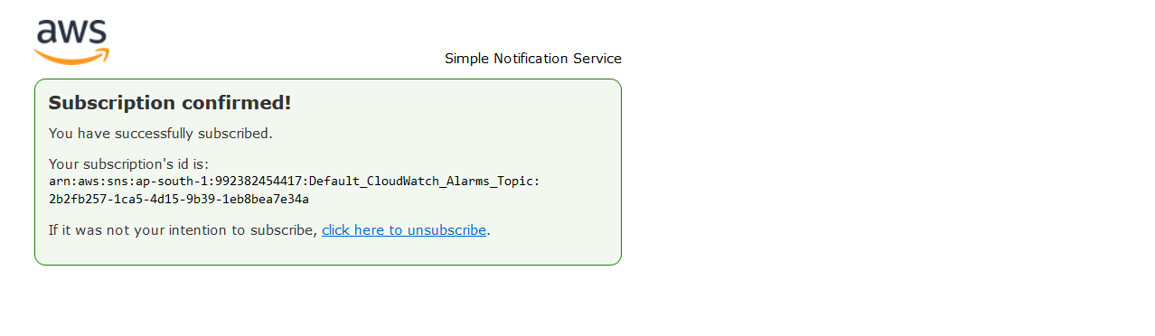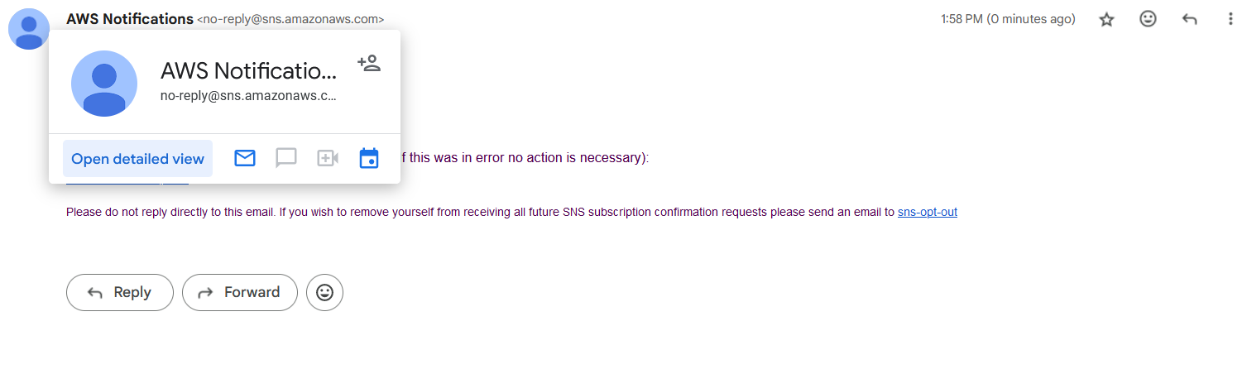

* We can unsubscribe or delete subscription from the Amazon SNS dashboard



